AWS Task-2

Task Description:

Set up a VPC with an Internet gateway, create a public subnet with 256 IP addresses, a private subnet with 256 IP addresses, make a route table connecting the Internet gateway and the subnets, and launch a Linux EC2 instance by using the above VPC and public subnet.

Step1: Creating VPC ‘Task-VPC’

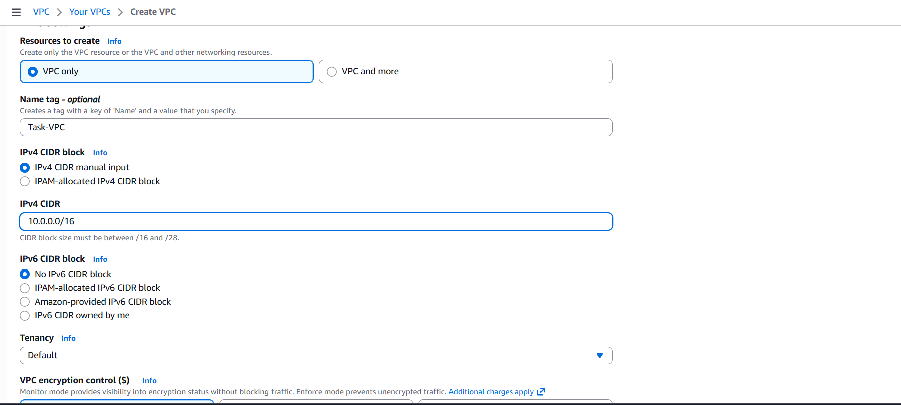

Step2: Creating subnets
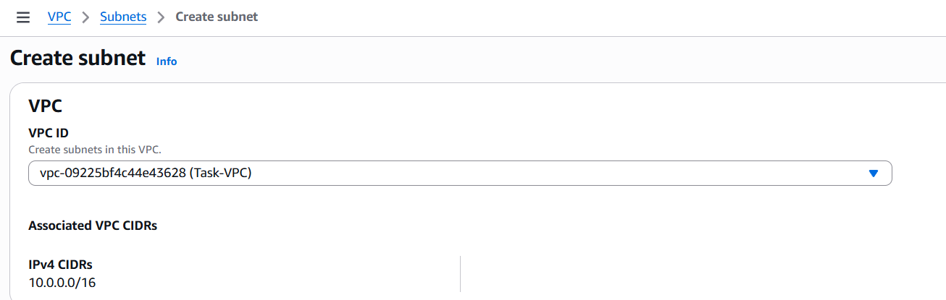

Public subnet with 256 IPs
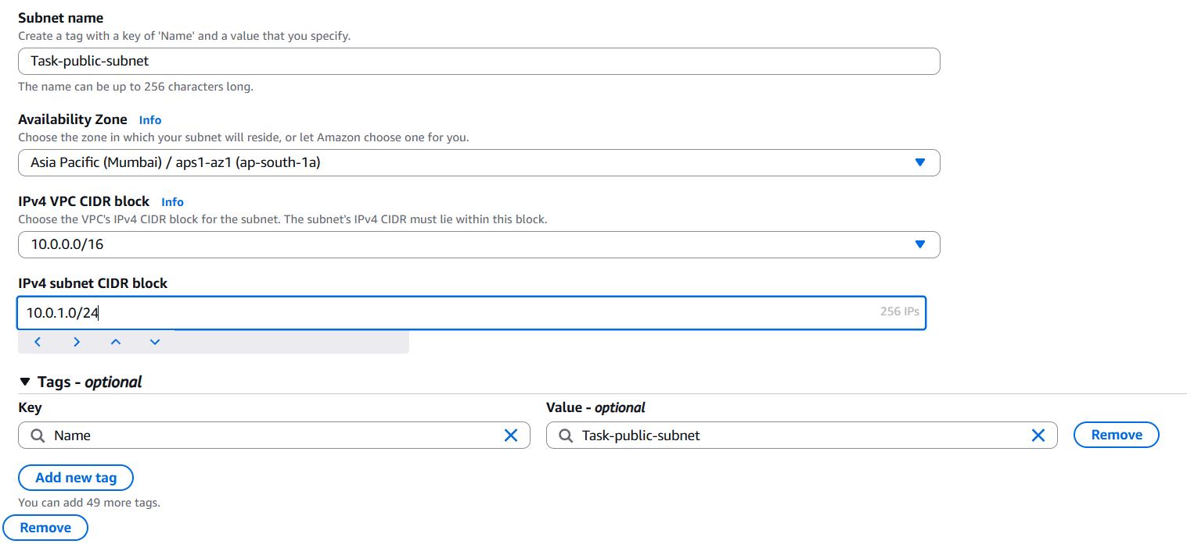
Private subnet with 256 IPs
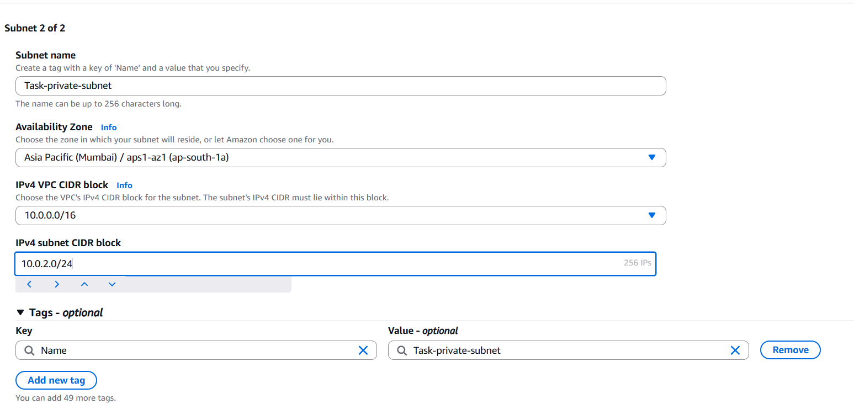

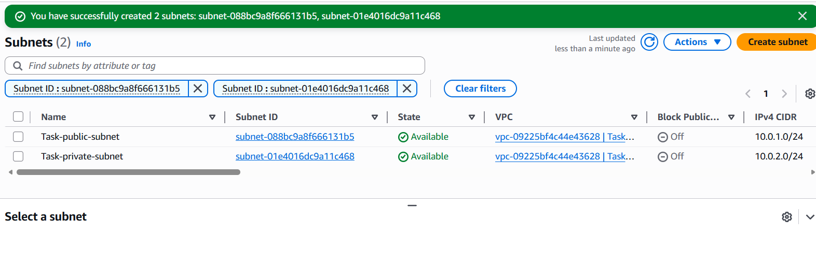
Step 3: Launching an EC2 instance with created VPC and select public subnet in network.
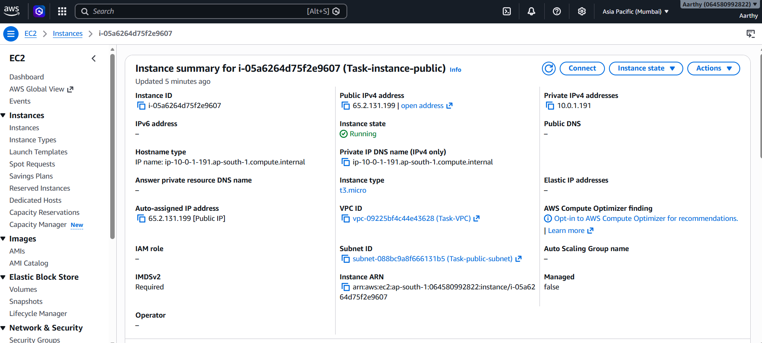

Not able to connect as the instance is not in public subnet

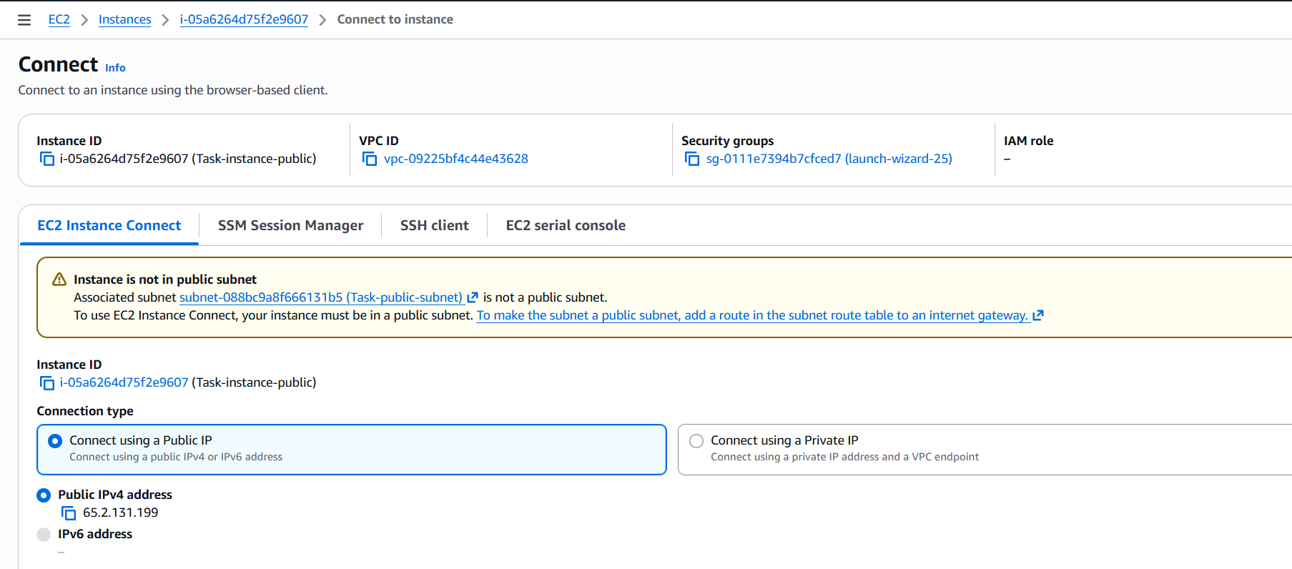
Step 4: Create a internet gateway and attach to the VPC created.
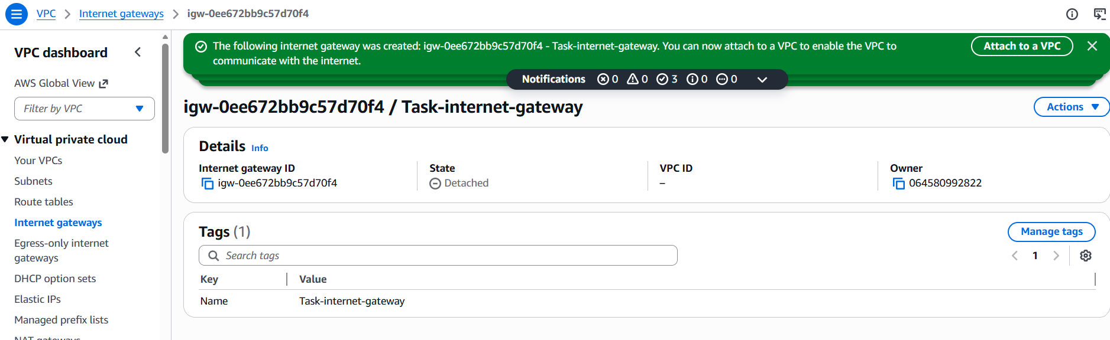

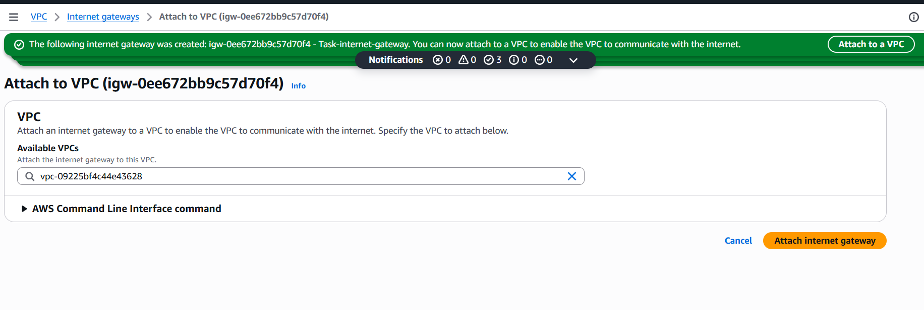
Step 5: Select public IP subnet (which we named as public) and go to route table and edit route with the internet gateway created in previous step.
This will make an entry to internet gateway which will make the selected subnet as public.
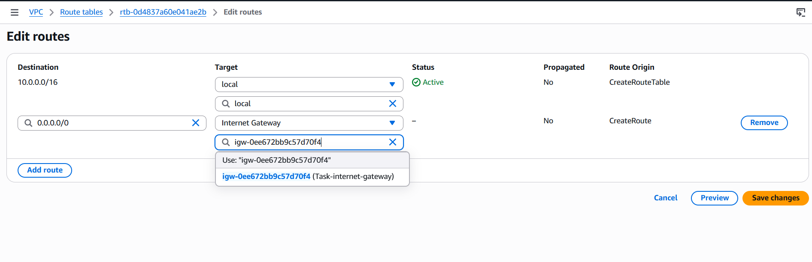
Step 6: Now EC2 instance connection happened without any error since the instance is in actual public subnet. (which happened only when we created a internet gateway and route the path for this subnet)
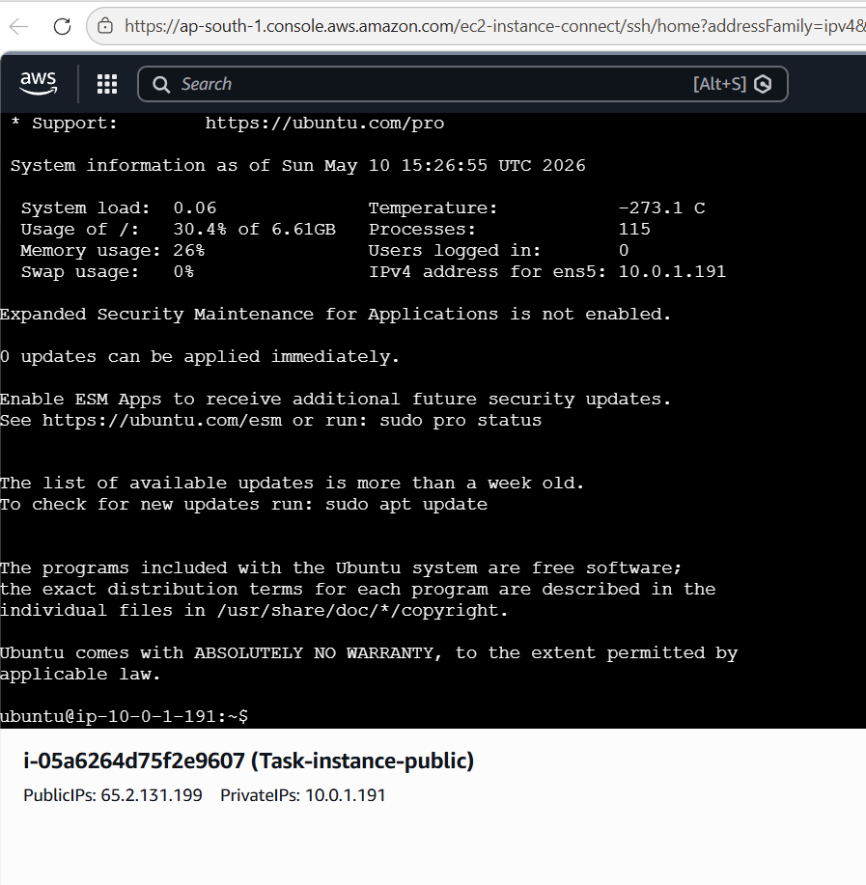
I HAVE A QUERY
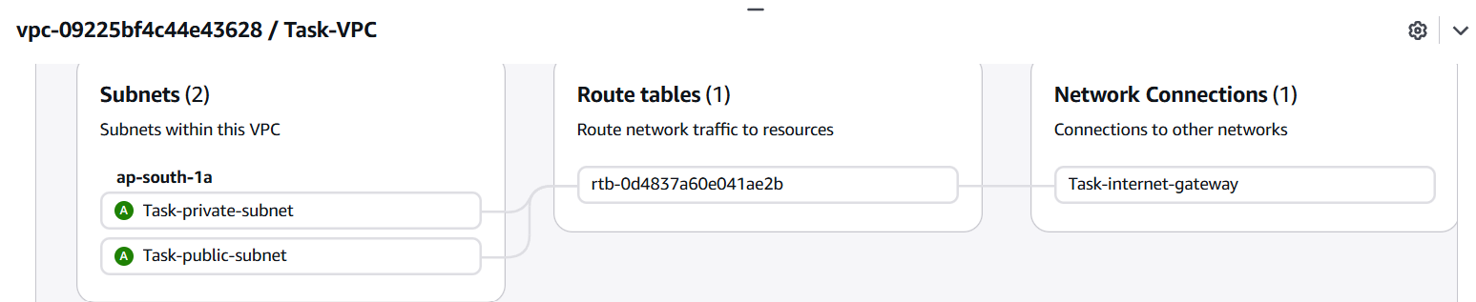

We have created the internet gateway and route table attached to the VPC created.
Selecting a subnet and route table is edited where the created internet gateway is attached to make this subnet the actual public subnet.

But in above image both the public and private subnet is showing the route table and internet gateway connected.

- Internet gateway is created on VPC level.
- Route table is edited for one specific subnet and internet gateway attached.
But the above image shows private subnet also in connect with route table and internet gateway.

Please clarify. Why does the connection shows same for both private and public subnet in above image.

